**UNIT 2**

**FEEDBACK AND SIGNAL GENERATORS:**

Feedback Concepts, Advantages of Voltage series Negative feedback, Oscillator Operation, Barkhausen Criterion, RC Phase Shift Oscillator, Wein Bridge Oscillator, Crystal Oscillator (Only Concepts, Working, Waveforms, No mathematical derivations).

**OPERATIONAL AMPLIFIERS:**

Op-Amp basics, Practical Op-amp circuits- Inverting Amplifier, Non Inverting Amplifier,Voltage Follower, Summer, Integrator, Differentiator(Only Concepts, Working, Waveforms, No mathematical derivations)

# Negative Feedback:

# The block diagram of a feedback amplifier is shown in fig.

# 

# Fig Simple block diagram of feedback amplifier.

# Gain with feedback:

# 

# Gain stability with feedback:

# 

**Advantages of negative feedback amplifiers:**

1. Input impedance increases by a factor of 1+Aβ
2. Output impedance decreases by a factor of 1+Aβ
3. Bandwidth increases by a factor of 1+Aβ
4. Distortion decreases by a factor of 1+Aβ
5. Noise decreases by a factor of 1+Aβ
6. Stability of the gain improves by a factor of 1+Aβ

**Barkhausen Conditions for Oscillation:**

It asserts that if A is the gain of the amplifying element in the circuit and β is the feedback path transfer function, so βA is the loop gain around the circuit's feedback loop, the circuit will maintain steady-state oscillations only at frequencies for which:

1. The loop gain is equal to one in absolute magnitude, which means that |βA|=1
2. The phase shift through the loop is either zero or an integer multiple ∠βA=2πn,n=0,1,2,…

RC Phase Shift Oscillator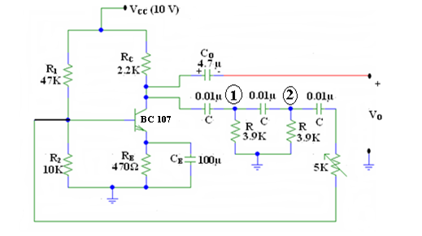

$$f_{0}=\frac{1}{2πRC\sqrt{6+4K}}$$

**Ideal Graph**

+

-

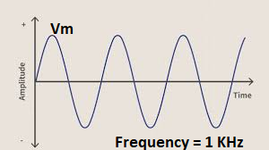

Wein Bridge Oscillator

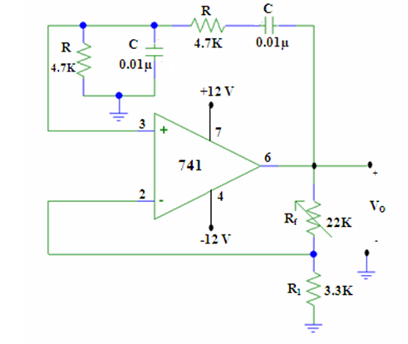

$$f_{0}=\frac{1}{2πRC}$$

**Ideal graph**

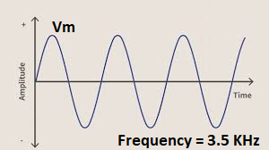

.

**Crystal Oscillator** (Case Study)

A **crystal oscillator** is an [electronic oscillator](https://en.wikipedia.org/wiki/Electronic_oscillator) [circuit](https://en.wikipedia.org/wiki/Electrical_circuit) that uses a [piezoelectric](https://en.wikipedia.org/wiki/Piezoelectricity) [crystal](https://en.wikipedia.org/wiki/Crystal) as a [frequency-selective element](https://en.wikipedia.org/wiki/Frequency_selective_surface). The oscillator frequency is often used to keep track of time, as in [quartz wristwatches](https://en.wikipedia.org/wiki/Quartz_clock), to provide a stable [clock signal](https://en.wikipedia.org/wiki/Clock_signal) for [digital](https://en.wikipedia.org/wiki/Digital_data) [integrated circuits](https://en.wikipedia.org/wiki/Integrated_circuit), and to stabilize frequencies for [radio transmitters](https://en.wikipedia.org/wiki/Radio_transmitter) and [receivers](https://en.wikipedia.org/wiki/Radio_receiver). The most common type of piezoelectric resonator used is a [quartz](https://en.wikipedia.org/wiki/Quartz) crystal, so oscillator circuits incorporating them became known as crystal oscillators. However, other piezoelectricity materials including [polycrystalline](https://en.wikipedia.org/wiki/Polycrystalline) ceramics are used in similar circuits.

A crystal oscillator relies on the slight change in shape of a quartz crystal under an [electric field](https://en.wikipedia.org/wiki/Electric_field), a property known as inverse [piezoelectricity](https://en.wikipedia.org/wiki/Piezoelectricity). A voltage applied to the [electrodes](https://en.wikipedia.org/wiki/Electrode) on the crystal causes it to change shape; when the voltage is removed, the crystal generates a small voltage as it elastically returns to its original shape. The quartz oscillates at a stable resonant frequency, behaving like an [RLC circuit](https://en.wikipedia.org/wiki/RLC_circuit), but with a much higher [Q factor](https://en.wikipedia.org/wiki/Q_factor) (less energy loss on each cycle of oscillation). Once a quartz crystal is adjusted to a particular frequency (which is affected by the mass of electrodes attached to the crystal, the orientation of the crystal, temperature and other factors), it maintains that frequency with high stability.

Quartz crystals are manufactured for frequencies from a few tens of [kilohertz](https://en.wikipedia.org/wiki/Kilohertz) to hundreds of megahertz. As of 2003, around two billion crystals are manufactured annually. Most are used for consumer devices such as [wristwatches](https://en.wikipedia.org/wiki/Wristwatch), [clocks](https://en.wikipedia.org/wiki/Clock), [radios](https://en.wikipedia.org/wiki/Radio), [computers](https://en.wikipedia.org/wiki/Computer), and [cellphones](https://en.wikipedia.org/wiki/Cellphone" \o "Cellphone). However in applications where small size and weight is needed crystals can be replaced by [thin-film bulk acoustic resonators](https://en.wikipedia.org/wiki/Thin-film_bulk_acoustic_resonator), specifically if high frequency (more than roughly 1.5 GHz) resonance is needed. Quartz crystals are also found inside test and measurement equipment, such as counters, [signal generators](https://en.wikipedia.org/wiki/Signal_generator), and [oscilloscopes](https://en.wikipedia.org/wiki/Oscilloscope).

**Operational Amplifier and its applications**

**INTRODUCTION**

Op-Amp (operational amplifier) is a direct coupled multistage voltage amplifier with an extremely high gain. Opamp is basically an amplifier available in the IC form. The word “operational” is used because the amplifier can be used to perform a variety of mathematical operations such as addition, subtraction, integration, differentiation etc.

Figure 1 below shows the symbol of an Op-Amp.

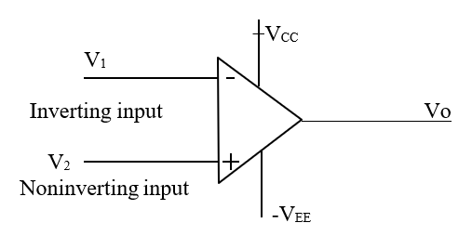

**Symbol of Op-Amp**

* It has two inputs and one output. The input marked “-“ is known as Inverting input and the input marked “+” is known as Non-inverting input

If a voltage Vi is applied at the inverting input ( keeping the non-inverting input at ground) as shown below.

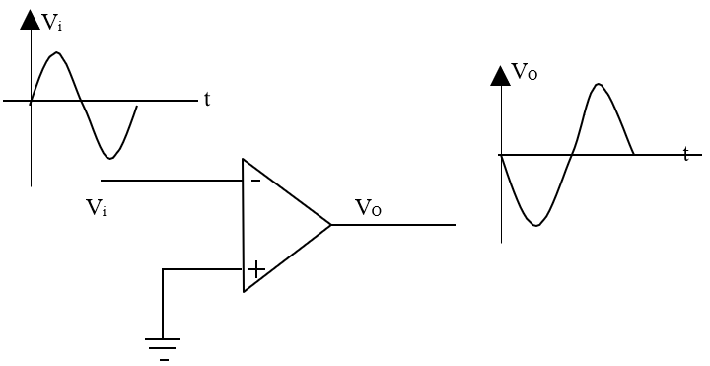

**Fig. Op-amp in inverting mode**

The output voltage Vo= -AVi is amplified but is out of phase with respect to the input signal by 1800.

* If a voltage Vi is fed at the non-inverting input ( Keeping the inverting input at ground) as shown below.

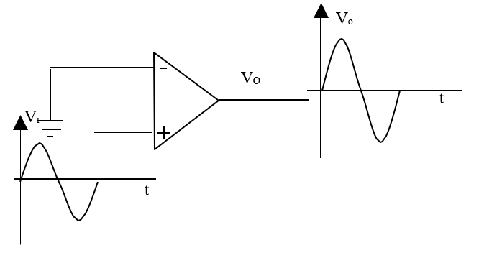

**Fig: Op-Amp in Non-inverting mode**

The output voltage Vo= AVi is amplified and in-phase with the input signal.

* If two different voltages V1 and V2 are applied to an ideal Op-Amp as shown below.

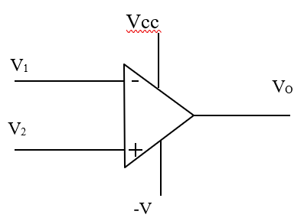

**Fig. Ideal Op-Amp**

The output voltage will be Vo = A(V1 – V2)

i.e the difference of the two voltages is amplified. Hence an Op-Amp is also called as a High gain differential amplifier.

**Concept of Virtual ground**

We know that , an ideal Op-Amp has perfect balance (ie output will be zero when input voltages are equal).

Hence when output voltage Vo = 0, we can say that both the input voltages are equal ieV1= V2.

V1

Vo

Ri

V2

.**Fig. Concept of Virtual ground**

Since the input impedances of an ideal Op-Amp is infinite ( Ri =∞ ). There is no current flow between the two terminals.

Hence when one terminal ( sayV2) is connected to ground (ieV2= 0) as shown.

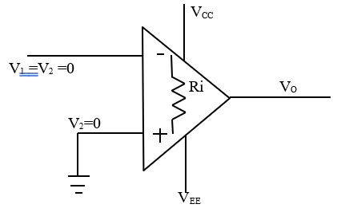

**Fig. Concept of Virtual ground**

Then because of virtual ground V1 will also be zero

**Characteristics of an Ideal Op-Amp**

An ideal Op-Amp has the following characteristics.

1. Infinite voltage gain ( ie AV =∞)
2. Infinite input impedance (Ri = ∞)
3. Zero output impedance(Ro =0)
4. Infinite Bandwidth (B.W. = ∞)
5. Infinite Common mode rejection ratio (ie CMRR =∞)
6. Infinite slew rate (ie S=∞)
7. Zero power supply rejection ratio ( PSRR =0)ie output voltage is zero when power supply VCC =0
8. Zero offset voltage(ie when the input voltages are zero, the output voltage will also be zero)
9. Perfect balance (ie the output voltage is zero when the input voltages at the two input terminals are equal)
10. The characteristics are temperature independent.

**Typical Specifications of general purpose Op-amp**

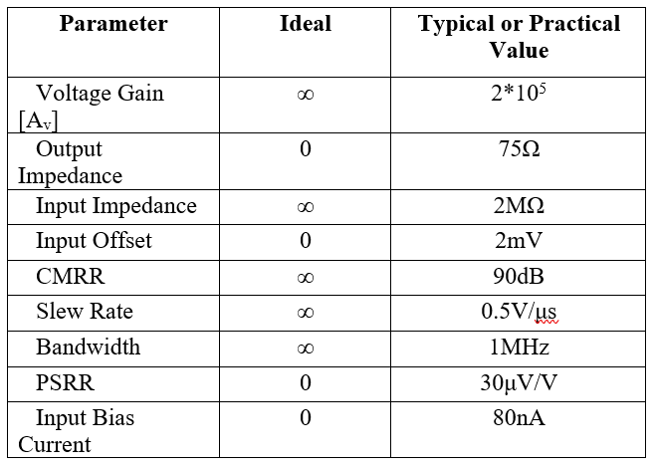

**Definitions**

1. **Slew rate(S):** It is defined as “ The rate of change of output voltage per unit time”

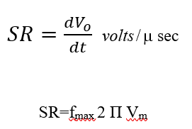

Ideally slew rate should be as high as possible. But its typical value is 0.5 V/μ-sec.

1. **Common Mode Rejection Ratio(CMRR):** It is defined as “ The ratio of differential voltage gain to common-mode voltage gain”.

**CMMR = Differential mode gain / Common-mode gain**

**CMRR = 20log|Ad/Ac| dB**

**Pin Configuration of Opamp(741)**

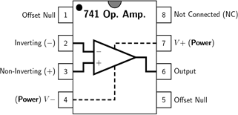

**Applications of Op-Amp**

An Op-Amp can be used as

1. Inverting Amplifier
2. Non-Inverting Amplifier
3. Voltage follower
4. Summer
5. Integrator
6. Differentiator

**1. Inverting Amplifier**

An inverting amplifier is one whose output is amplified and is out of phase by 180 with respect to the input

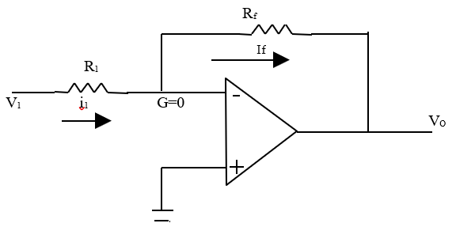

**Fig: Inverting Amplifier**

The point “G” is called virtual ground and is equal to zero.

**Inverting Op-amp**

* Input Signal Vi is applied to the inverting input terminal through resistor R1.
* Non inverting terminal is grounded.
* The feedback from output is given to the inverting terminal through Rf.

Vd = V2 –V1 = Vo = 0

From the concept of Virtual ground,

V_1=V2=0

Due to high input impedance of Op-amp, current flowing into inverting input terminal is zero. Thus same current flows through R1 and Rf.

$I_{1}= I_{F}$---------------------------------------(1)

By KCL we have

$I_{1 }= \frac{V_{i }-V_{1}}{R_{1}} =\frac{V_{i}}{R_{1}}$------------------(2)

$I_{f }= \frac{V_{1 }-V_{0}}{R_{f}} =\frac{{-V}_{0}}{R_{f}}$------------------(3)

From (1),(2) and (3),

$$\frac{V_{i}}{R_{1}} =\frac{{-V}_{0}}{R_{f}}$$

$A_{v }=\frac{V_{o}}{V_{i}}=\frac{{-R}_{f}}{R_{1}}$------------Gain for Inverting Op-amp

Where the gain of the amplifier and negative sign indicates that the output isinverted with respect to the input.

Vi

t

VO

t

**Fig Waveforms of Inverting Amplifier**

**2. Non- Inverting Amplifier**

A non-inverting amplifier is one whose output is amplified and is in-phase with the input.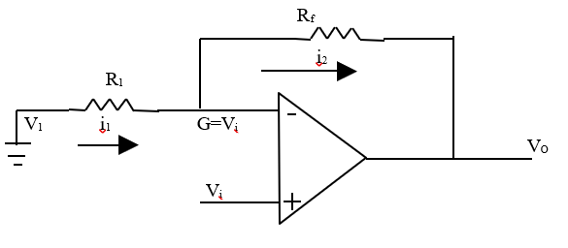

**Fig Non Inverting Amplifier**

**Non Inverting Op-amp**

* Input Signal Vi is applied to the non - inverting input terminal.
* Inverting terminal is grounded through resistor R1.
* The feedback from output is given to the inverting terminal through Rf.

$V_{2}$ =Vi-------------------------------(1)

Due to virtual ground,

=V2------------------------------(2)

=V1=V2

Due to high input impedance of Op-amp, current flowing into inverting input terminal is zero. Thus same current flows through R1 and Rf.

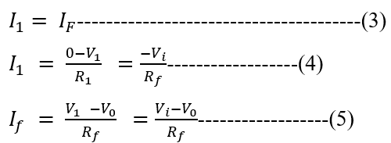

Using (3),equating (4) and(5),

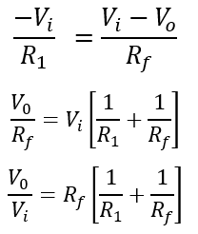

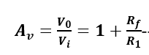-----------------Gain for non inverting Op-amp

**3. Voltage follower**

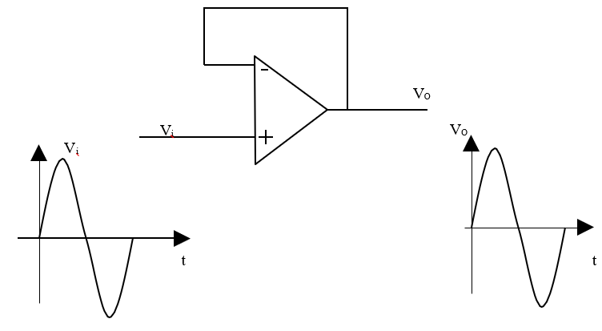

**Fig. Voltage follower**

Voltage follower is one whose output is equal to the input.

The voltage follower configuration shown above is obtained by short circuiting “Rf” and open circuiting “R1” connected in the usual non-inverting amplifier.

Thus all the output is fed back to the inverting input of the op-Amp.

Consider the equation for the output of non-inverting amplifier

When Rf = 0 short circuiting R1= ∞ open circuiting

Input Signal Vi is applied to the non - inverting input terminal.

$V_{2}$ =Vi-------------------------------(1)

Inverting terminal is directly connected to the output..

=V1-------------------------------(2)

From (1) and (2)

$V_{0}$ =Vi

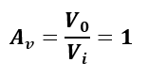

Feedback factor for Voltage Follower

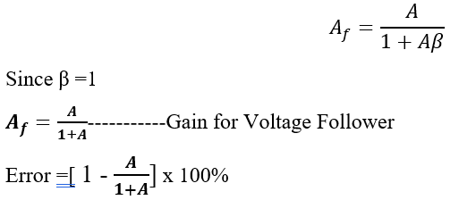

Therefore the output voltage will be equal and in-phase with the input voltage. Thus voltage follower is nothing but a non-inverting amplifier with a voltage gain of unity.

**4. Summer**

Inverting adder is one whose output is the inverted sum of the constituent inputs

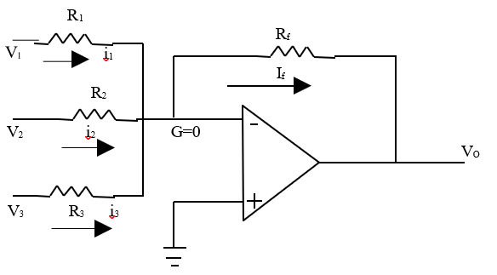

**Fig Summer**

Since non inverting terminal is grounded,

$V_{B}$ = 0

And

$V_{A}$ =VB  = G= 0[Virtual Ground]

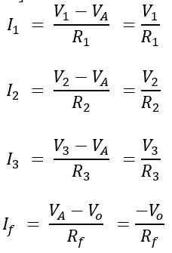

Applying KCL at node A

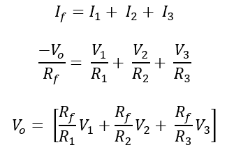

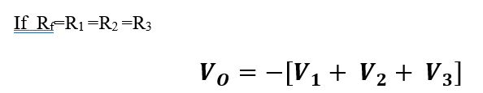

Hence it can be observed that the output is equal to the inverted sum of the inputs.

**5. Integrator**

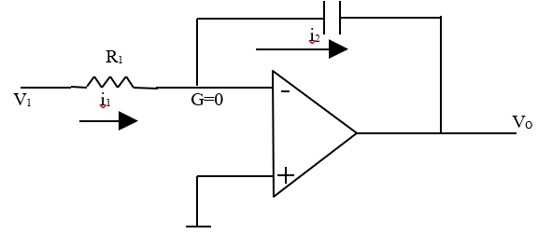

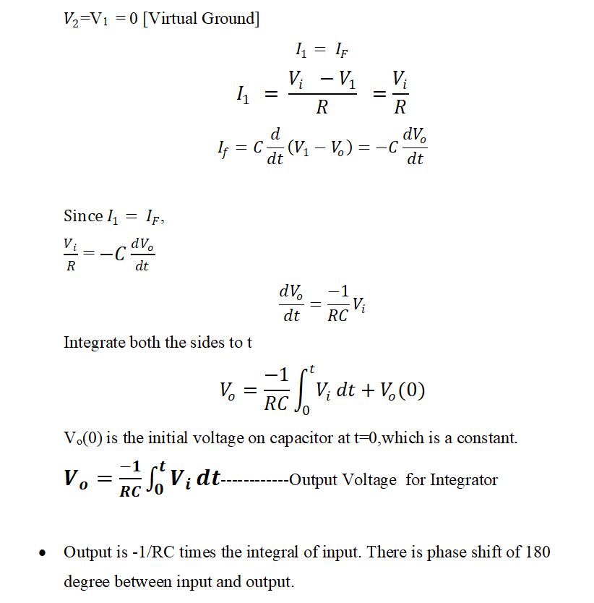

**6. Differentiator**

A differentiator is one whose output is the differentiation of the input

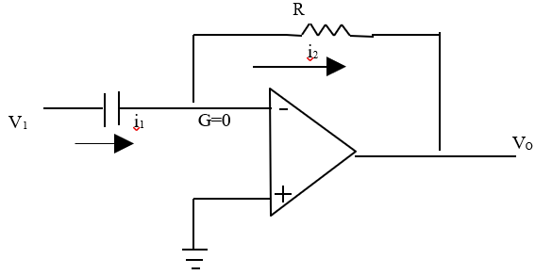

**Fig Differentiator Circuit**

